PASTA Model Framework
Process of Attack Simulation and Threat Analysis

Scenario
You’re part of the growing security team at a company for sneaker enthusiasts and collectors. The business is preparing to launch a mobile app that makes it easy for their customers to buy and sell sneakers.
As part of the team, you are tasked with performing a threat model of the application using the PASTA framework. This will ensure the app is secure before launch and aligned with business and security requirements.

Components of PASTA
- Define Business and Security Objectives
- Define the Technical Scope
- Decompose Application (Data Flow Diagram)
- Threat Analysis
- Vulnerability Analysis
- Attack Modeling (Attack Tree)
- Risk Analysis and Impact
- Implementation

Stages | Sneaker company
I. Define business and security objectives | - The app must allow buyers and sellers to interact seamlessly through sign-ups, logins, messaging, and rating systems.  - Transactions should be fast, reliable, and support multiple secure payment options.  - The company must prioritize data privacy and legal compliance to build user trust.
II. Define the technical scope | - I would prioritize SQL first because it handles sensitive user and transaction data directly. Poorly secured SQL queries can expose the database to injection attacks, leading to data theft or manipulation. While encryption (PKI, SHA-256) secures transmission and storage, the database is the prime target where attackers often attempt exploitation.
III. Decompose application | 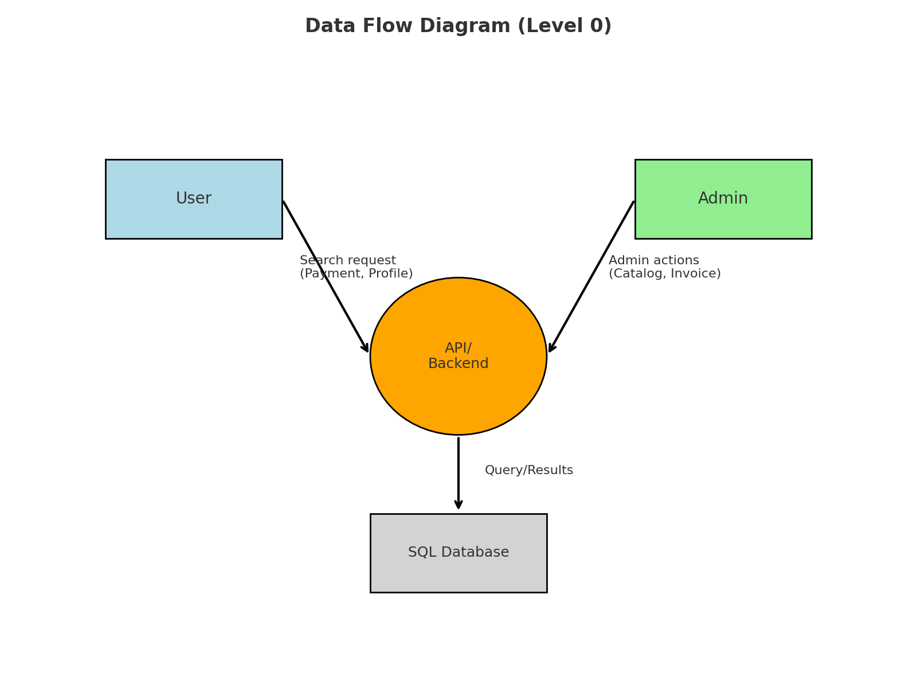
IV. Threat analysis | - SQL injection attacks on poorly secured queries could expose or alter sensitive data.  - Session hijacking through weak login credentials or stolen tokens could allow attackers unauthorized access.
V. Vulnerability analysis | - Failure to use prepared statements in SQL queries makes the database vulnerable to injection attacks.  - Weak authentication mechanisms (e.g., weak password policies or lack of multi-factor authentication) increase the risk of account compromise.
VI. Attack modeling | 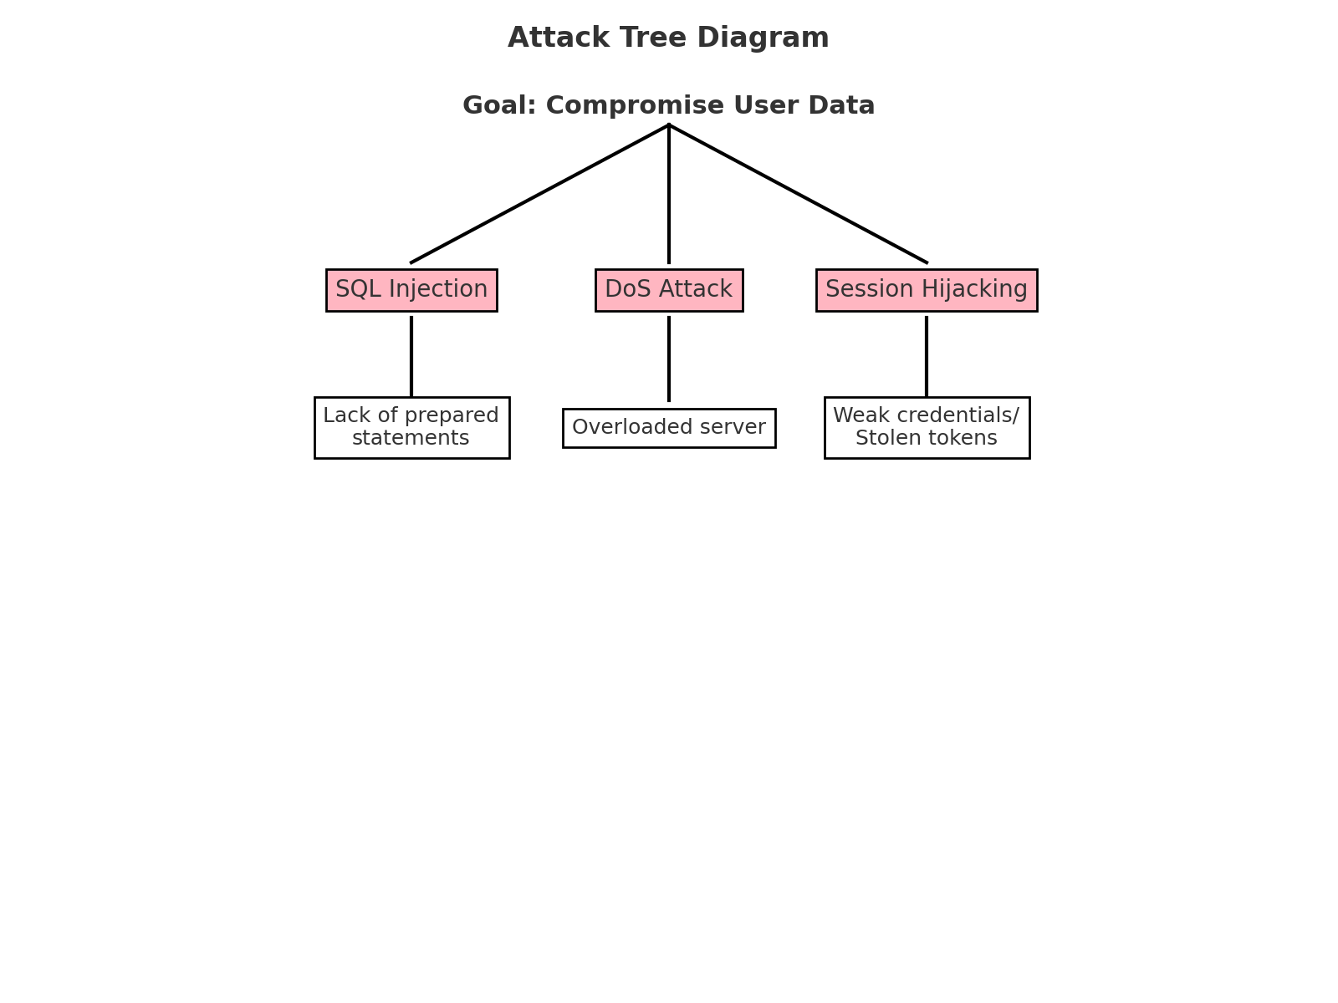
VII. Risk analysis and impact | - Implement input validation and parameterized queries to prevent SQL injection.  - Enforce multi-factor authentication (MFA) and strong password policies.  - Apply TLS/SSL encryption for secure communication and protect session tokens.  - Conduct regular penetration testing and code reviews to identify and fix vulnerabilities before attackers can exploit them.

